

DEPARTMENT OF COMPUTER ENGINEERING & APPLICATIONS

Institute of Engineering & Technology

# Lab Manual

|  |  |
| --- | --- |
| Submitted by: Dheeraj Kumar  Subject : Machine Learning Lab  Subject Code: BCSE0133  University Roll no:- 2115000357  Course: B.Tech. Section: C(18)  Year: III Semester: V  Submitted To: Dr. Premnarayan Arya  Department of Computer Engineering & Application | Page 1 of 3 |

Lab Manual of Machine Learning

|  |  |  |
| --- | --- | --- |
| Exp.  No. | Program | Page No. |
| 1 | Introduction to Pandas, Upload data and data preprocessing |  |
|  | Introduction to Numpy and Matplotlib library in Python |  |
| 2 | Implement Linear Regression with one variable in Python using Salary Prediction Data : https://www.kaggle.com/datasets/krishnaraj30/salary-prediction-datasimple-linear-regression |  |
| 3 | Implement Linear Regression with multiple variables in Python using Housing  Prices Dataset: https://www.kaggle.com/datasets/yasserh/housing-prices-dataset |  |
| 4 | Implement binary classification using Logistic Regression in Python using Bank Customer Churn Dataset: https://www.kaggle.com/datasets/gauravtopre/bankcustomer-churn-dataset |  |
| 5 | Implement Principle Component Analysis (PCA) in Python using Pizza Dataset:  https://data.world/sdhilip/pizza-datasets |  |
| 6 | Implement Support Vector Machine (SVM) classifier in Python using Cell  Sample: https://cf-courses-data.s3.us.cloud-object-storage.appdomain.cloud/  IBMDeveloperSkillsNetwork-ML0101EN-SkillsNetwork/labs/Module%203/data/ cell_samples.csv |  |
| 7 | Implement multi-classification using Artificial Neural Network (ANN) in Python  MNIST: https://www.kaggle.com/datasets/hojjatk/mnist-dataset |  |
| 8 | Implement Decision Tree (DT) classification in Python using Cell Sample:  https://cf-courses-data.s3.us.cloud-object-storage.appdomain.cloud/  IBMDeveloperSkillsNetwork-ML0101EN-SkillsNetwork/labs/Module%203/data/ |  |

Page 2 of 3

|  |  |  |
| --- | --- | --- |
|  | cell_samples.csv |  |
| 9 | Implement K-Nearest Neighbor (KNN) in Python using Cell Sample: https://cfcourses-data.s3.us.cloud-object-storage.appdomain.cloud/  IBMDeveloperSkillsNetwork-ML0101EN-SkillsNetwork/labs/Module%203/data/ cell_samples.csv |  |
| 10 | Implement Random Forest in Python using Cell Sample: https://cf-coursesdata.s3.us.cloud-object-storage.appdomain.cloud/IBMDeveloperSkillsNetwork-  ML0101EN-SkillsNetwork/labs/Module%203/data/cell_samples.csv |  |
| 11 | Implement Naïve Bayes Claasifier (NB) in Python using Cell Sample: https://cfcourses-data.s3.us.cloud-object-storage.appdomain.cloud/  IBMDeveloperSkillsNetwork-ML0101EN-SkillsNetwork/labs/Module%203/data/ cell_samples.csv |  |
| 12 | Implement K-means Clustering in Python using Country Data:  https://www.kaggle.com/datasets/rohan0301/unsupervised-learning-on-country-data |  |
| 13. | Project: Estimation of diabetes or various other classification/regression task using regression or classification algorithms and their comparison. Loan_dataset:https://cf-courses-data.s3.us.cloud-objectstorage.appdomain.cloud/IBMDeveloperSkillsNetwork-ML0101EN-  SkillsNetwork/labs/FinalModule_Coursera/data/loan_train.csv |  |

**Experiment-1**

**Objective :-** Introduction to Pandas, Upload, data preprocessing, NumPy and Matplotlib library in Python.

**Implementation :-**

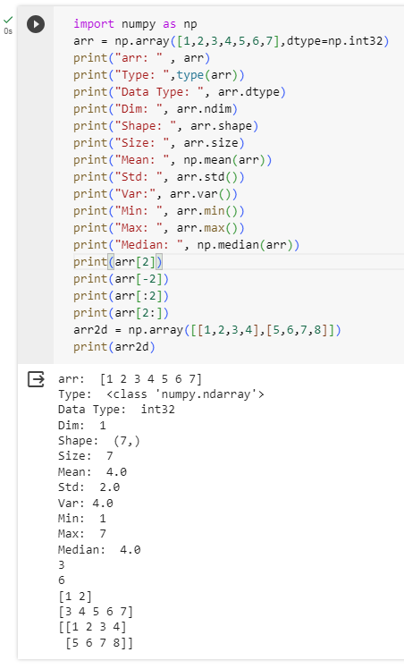

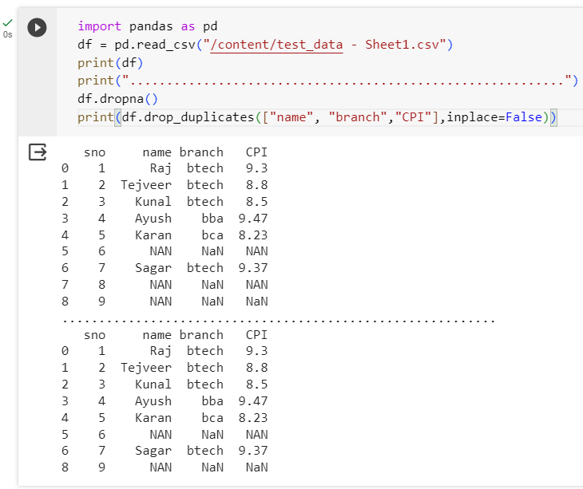

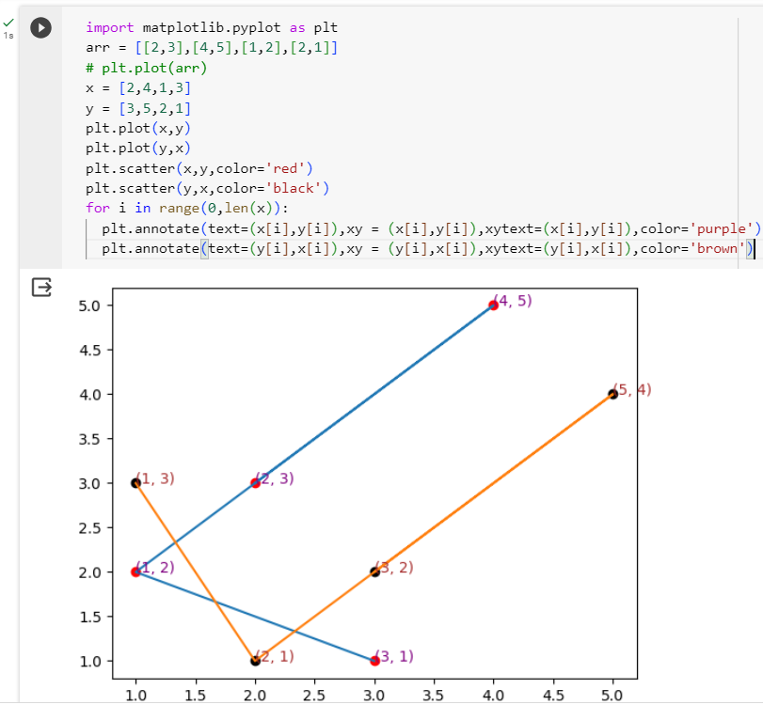

**Experiment-2**

**Objective :-** To Implement Linear Regression with one variable in Python

**Dataset:-**  <https://www.kaggle.com/datasets/krishnaraj30/salary-prediction->data-simple-linear-regression

**Implementation :-**

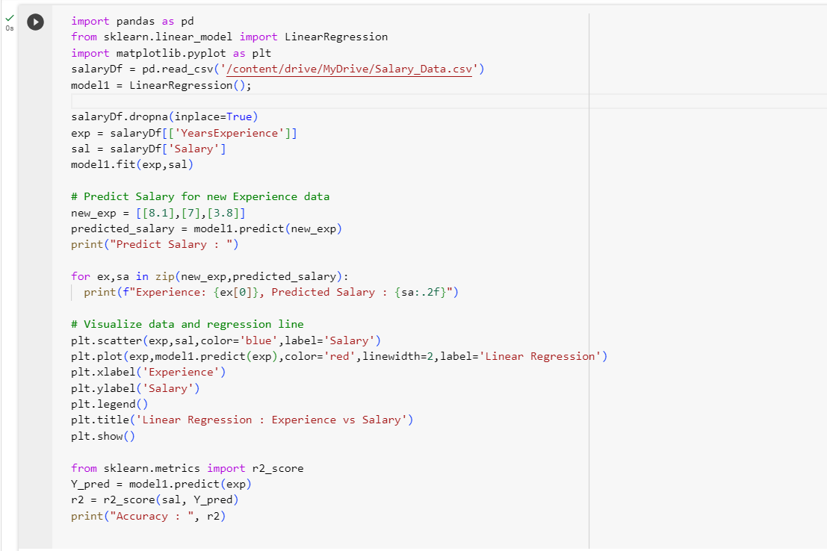

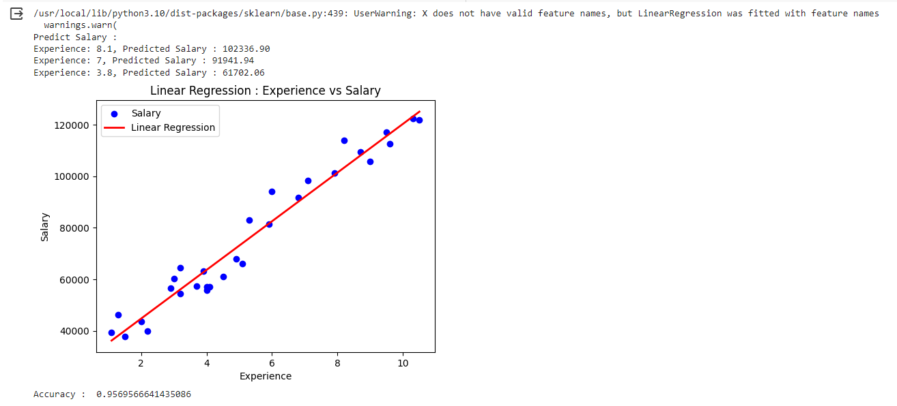

**Experiment-3**

**Objective :-** To Implement Linear Regression with Multiple variable in Python

**Dataset:-**  https://www.kaggle.com/datasets/yasserh/housing-prices-dataset

**Implementation :-**

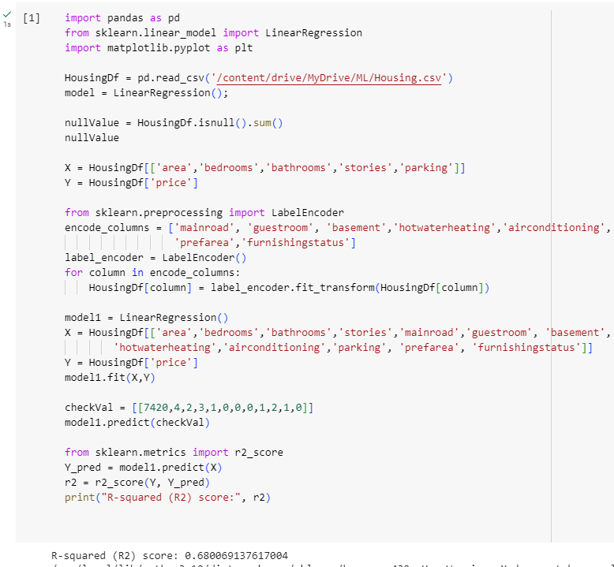

**Experiment-4**

**Objective :-** To Implement Binary Classification using Logistic Regression in Python

**Dataset:-**  <https://www.kaggle.com/datasets/gauravtopre/bank-customer->churn-dataset

**Implementation :-**

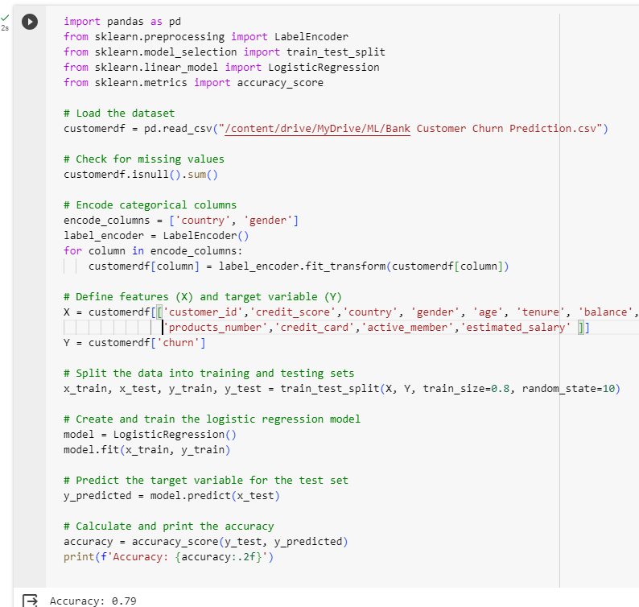

**Experiment-5**

**Objective :-** To Implement Principal Component Analysis in Python

**Dataset:-**  https://data.world/sdhilip/pizza-datasets

**Implementation :-**

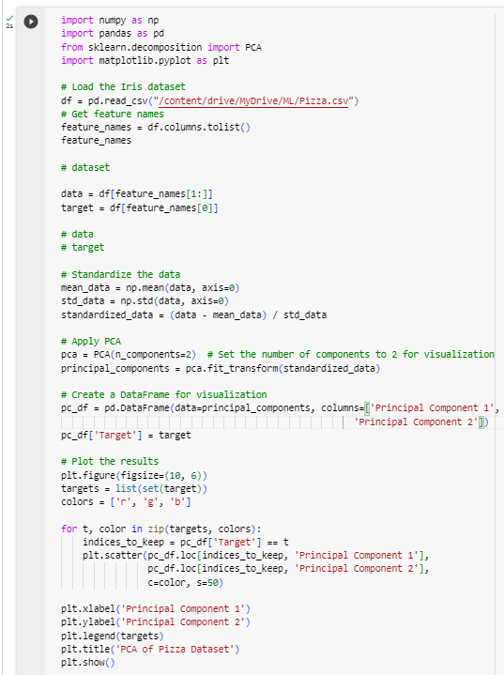

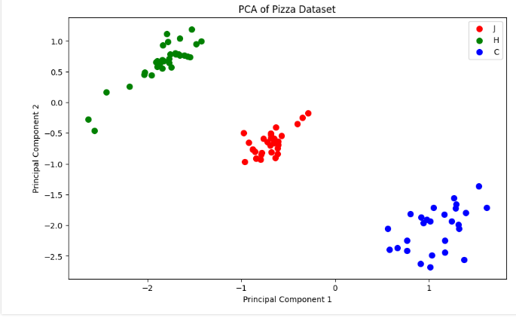

**Experiment-6**

**Objective :-** To Implement Support Vector Machine Classifier in Python

**Dataset:-**  https://archive.ics.uci.edu/ml/machine-learning-databases/iris/iris.data

**Implementation :-**

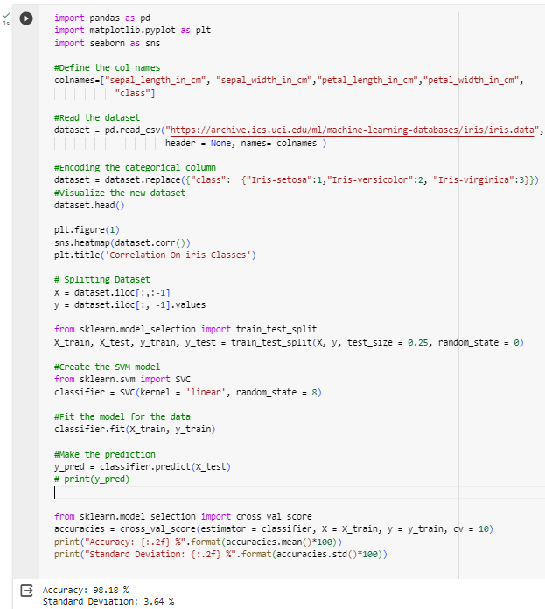

**Experiment-7**

**Objective :-** To Implement Multi-Classification using Artificial Neural Network in Python

**Dataset:-**  https://www.kaggle.com/datasets/hojjatk/mnist-dataset

**Implementation :-**

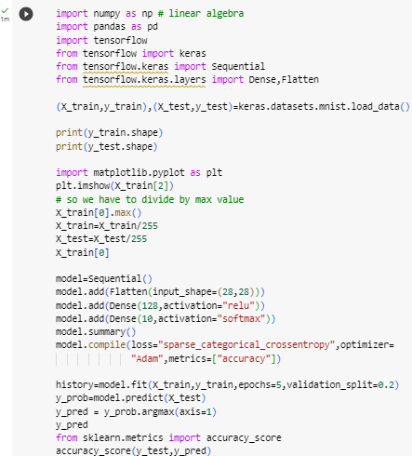

**Experiment-8**

**Objective :-** To Implement Decision Tree (DT) classification in Python

**Dataset:-**  https://cf-courses-data.s3.us.cloud-object-storage.appdomain.cloud/IBMDeveloperSkillsNetwork-ML0101EN-SkillsNetwork/labs/Module%203/data/cell_samples.csv

**Implementation :-**

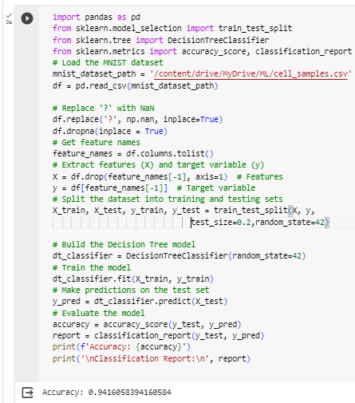

**Experiment-9**

**Objective :-** To Implement K-Nearest Neighbor (KNN) in Python

**Dataset:-**  https://cf-courses-data.s3.us.cloud-object-storage.appdomain.cloud/IBMDeveloperSkillsNetwork-ML0101EN-SkillsNetwork/labs/Module%203/data/cell_samples.csv

**Implementation :-**

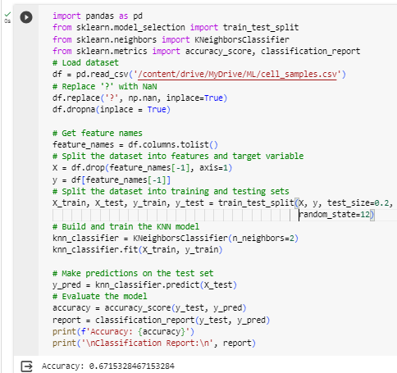

**Experiment-10**

**Objective :-** To Implement Random Forest in Python

**Dataset:-**  https://cf-courses-data.s3.us.cloud-object-storage.appdomain.cloud/IBMDeveloperSkillsNetwork-ML0101EN-SkillsNetwork/labs/Module%203/data/cell_samples.csv

**Implementation :-**

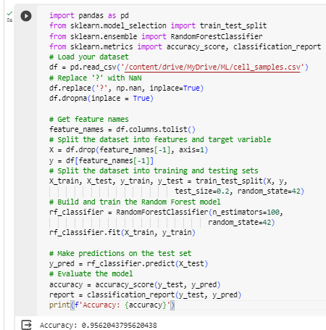

**Experiment-11**

**Objective :-** To Implement Naïve Bayes Classifier (NB) in Python

**Dataset:-**  https://cf-courses-data.s3.us.cloud-object-storage.appdomain.cloud/IBMDeveloperSkillsNetwork-ML0101EN-SkillsNetwork/labs/Module%203/data/cell_samples.csv

**Implementation :-**

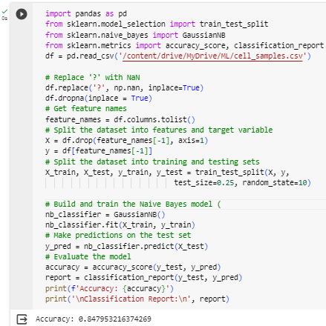

**Experiment-12**

**Objective :-** To Implement K-means Clustering in Python

**Dataset:-**  https://archive.ics.uci.edu/ml/machine-learning-databases/iris/iris.data

**Implementation :-**

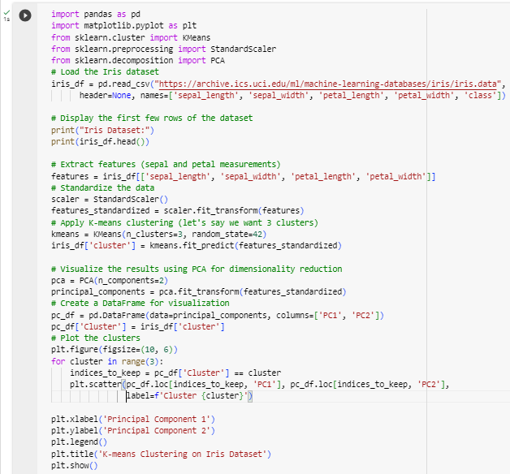

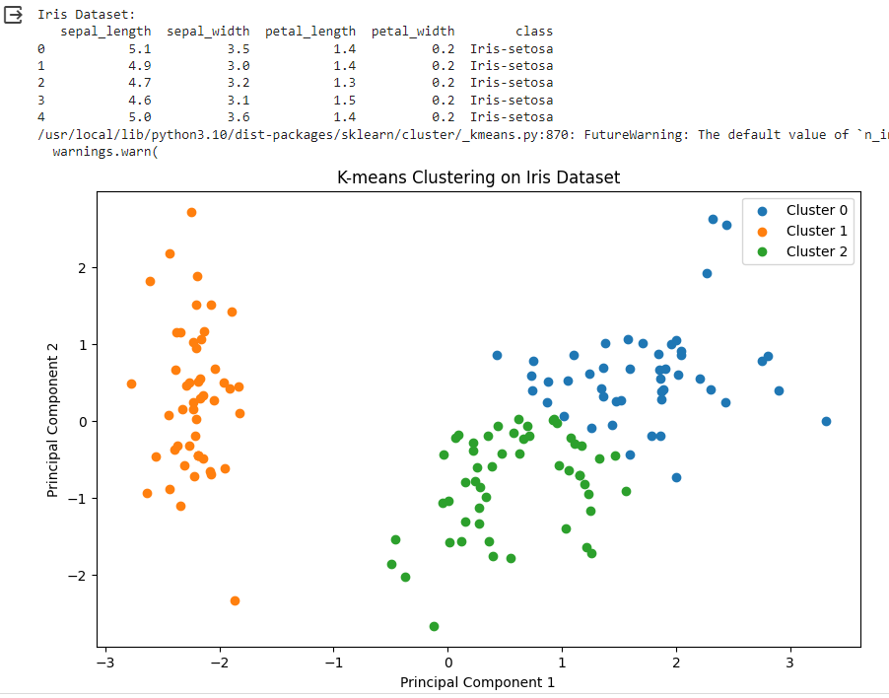

**Project**

**Objective :-** Classify the loan status using various classification algorithms and their comparison.

**Dataset:-**  <https://cf-courses-data.s3.us.cloud-object-storage.appdomain.cloud/IBMDeveloperSkillsNetwork-ML0101EN->SkillsNetwork/labs/FinalModule_Coursera/data/loan_train.csv

**Implementation :-**

